AD-HOC COMMANDS & PLAYBOOKS

1. Go to Ansible Controller

Cmd: cd /etc/ansible

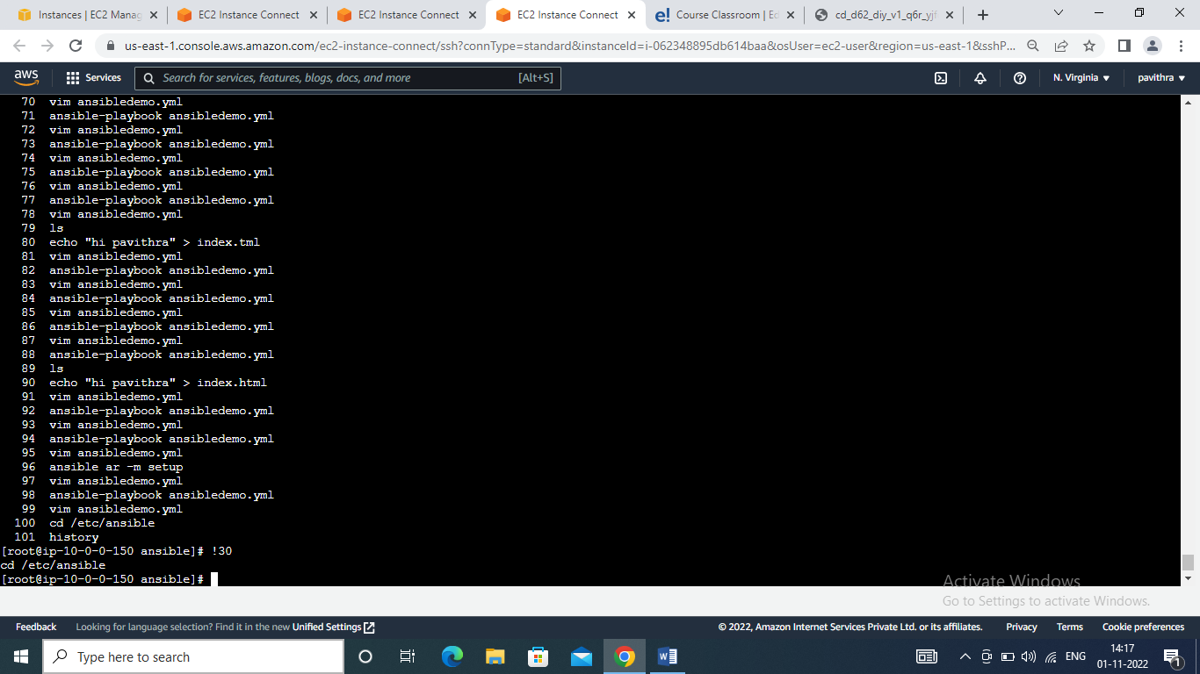

1. Write an ansible ad hoc command to execute a module that checks connection with ansible hosts

Cmd : ansible <groupname> -m ping

Ansible <groupname> -m setup

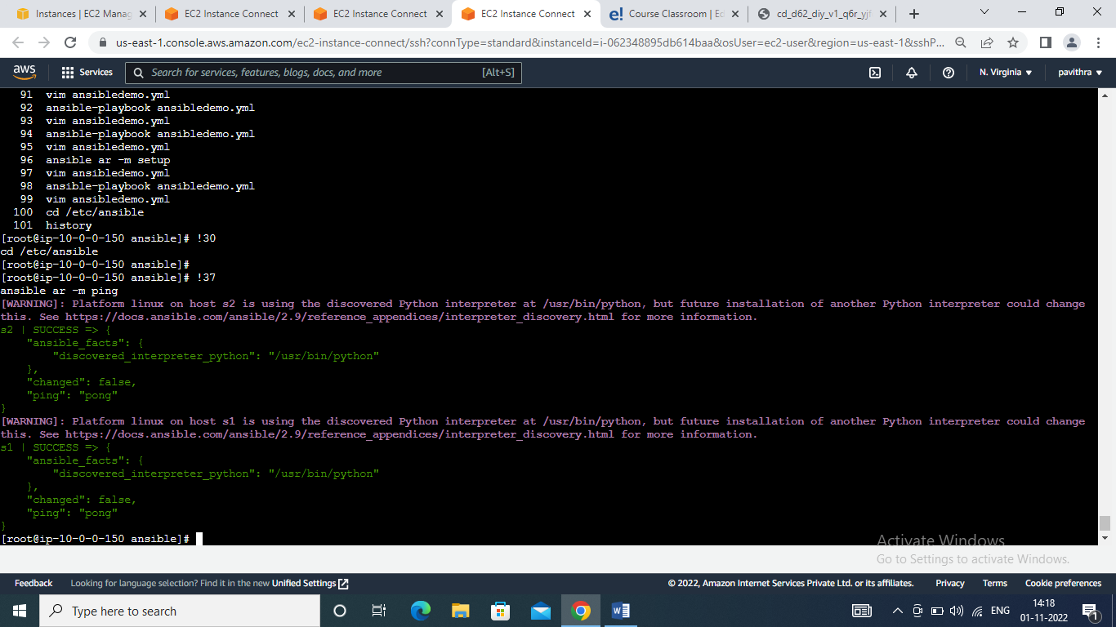

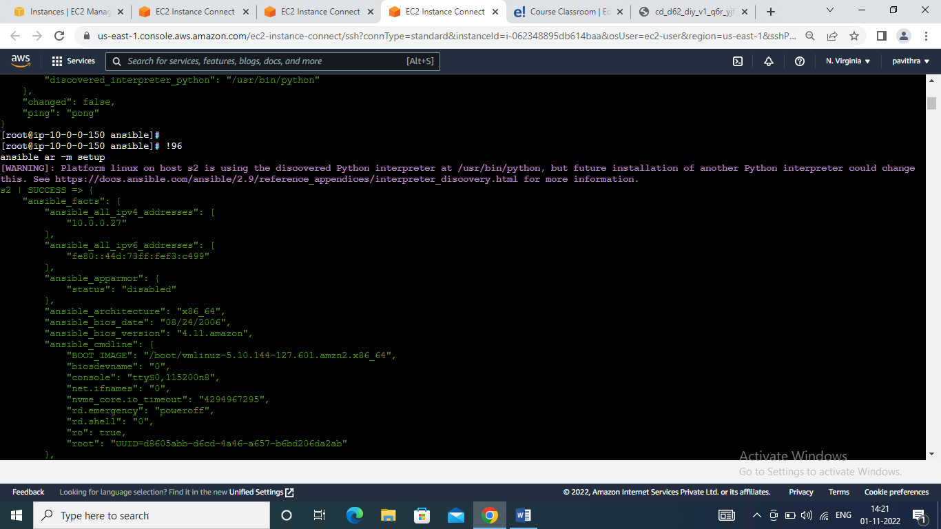

1. Write a simple playbook with host details, become a plugin, and tasks to copy files from source to destination.

Cmd :

---

- name:

hosts: all

become: true

become_user: root

vars:

a: git

tasks:

- command: "mkdir z10"

- yum: name={{a}} state=latest

- copy: src=/etc/ansible/index.html dest=/var/www/html

- service: name=httpd state=started

~

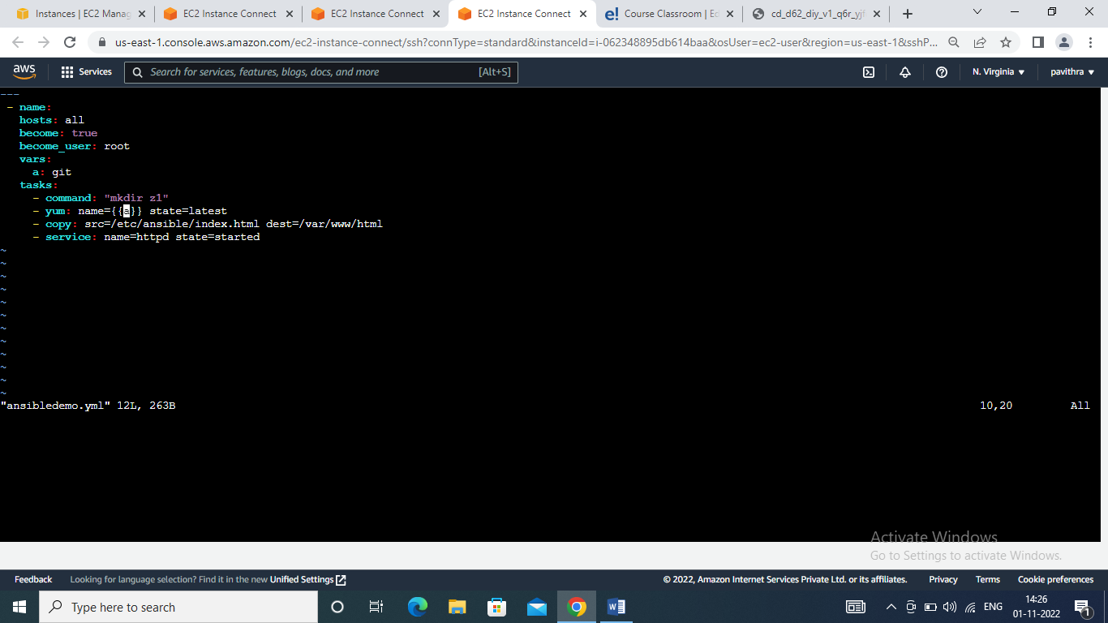

1. Validate the ansible-playbook code

Cmd : ansible-playbook ansibledemo.yml --syntax-check

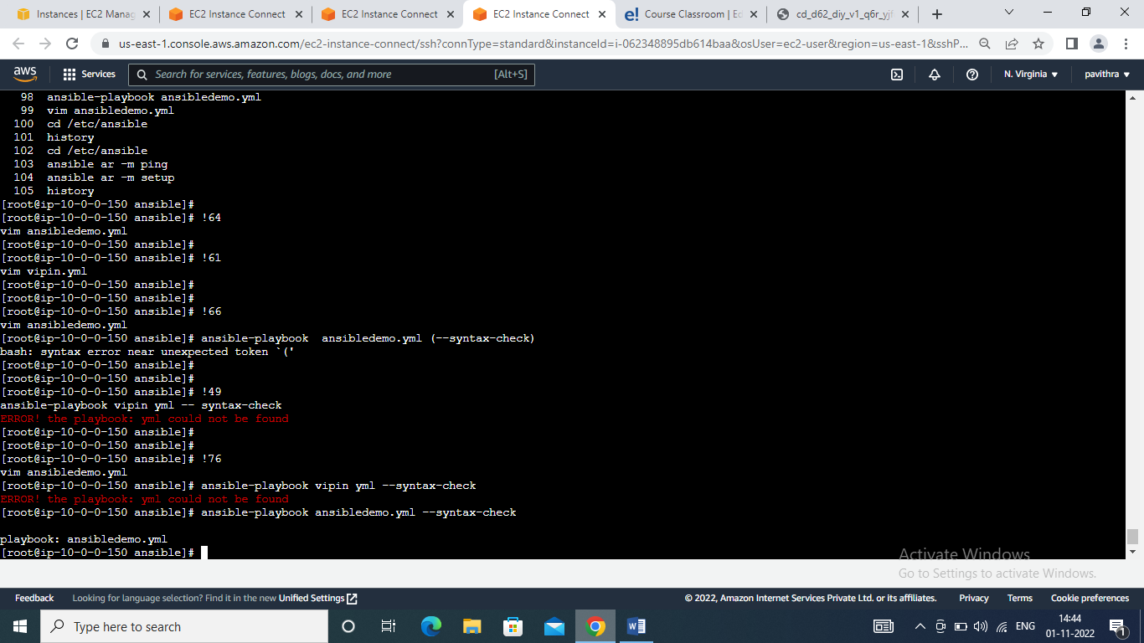

1. Execute the ansible code

Cmd : ansible-playbook ansibledemo.yml

